Geometry: Unit 7, Lesson 2
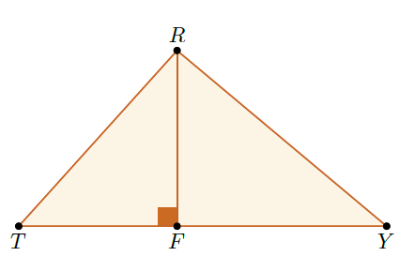
- $∆TRY$ with altitude $\overline{RF}$ is shown. If $m∠T=33°$, then what is $m∠TRF$?

$$m∠TRF=57°$$

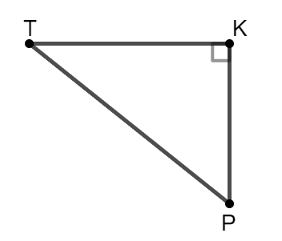
- $∆TKP$ where $m∠TKP=90°$ is shown. What is the hypotenuse?

$\overline{PT}$ is the hypotenuse

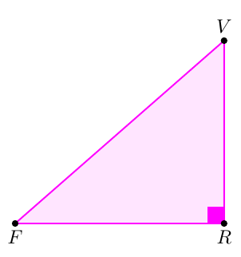
- $∆FVR$ where $m∠FRV=90°$ is shown. What are the legs of $∆FVR$?

$\overline{VR}$ and $\overline{FR}$

